COMP-610-AH2: Database Management Systems
Boston Hospital Case Study
Final Project
Vaishnavi keshetty

Introduction
This project aims to create a detailed database schema for BostonHospital, a healthcare institution. The schema incorporates tables, primary keys, foreign keys, and indexes to manage essential data concerning departments, staff, patients, appointments, and medical supplies. The design is intended to enhance performance, ensure data integrity, and support efficient operations.

Entity Relationship Diagram (ERD)

- Departments o Attributes: department_id, department_name, location, total_beds, telephone_extension
  - Relationships:
    - One department can have many staff members (via Staff_Department).
    - One department can admit many patients (Inpatients).
- Staff o Attributes: staff_id, first_name, last_name, address, sex, date_of_birth, telephone_number, insurance_number, position_name, current_salary, salary_scale, type_of_employment, hours_per_week, contract_type
  - Relationships:
    - A staff member can be associated with many departments (Staff_Department).
    - A staff member can have multiple qualifications (Qualifications).
    - A staff member can have multiple work experiences (WorkExperience).
    - A staff member can have multiple appointments with patients (Appointments).
    - A staff member can be associated with multiple requisitions (Requisitions).
- Qualifications o Attributes: qualification_id, staff_id, qualification_type, qualification_date, institution_name
  - Relationships:
    - Each qualification is linked to a staff member (Staff).
- WorkExperience
  - Attributes: experience_id, staff_id, position, start_date, finish_date, organization_name
  - Relationships:
    - Each work experience is linked to a staff member (Staff).
- Patients o Attributes: patient_id, first_name, last_name, address, telephone_number, date_of_birth, gender, marital_status, date_registered, next_of_kin_name, next_of_kin_relationship, next_of_kin_address, next_of_kin_telephone, local_doctor_name, local_doctor_clinic_no, local_doctor_address, local_doctor_telephone
  - Relationships:
    - A patient can have many appointments (Appointments).
    - A patient can be admitted to many departments (Inpatients).
    - A patient can be prescribed many medications (Medications).
- Appointments o Attributes: appointment_id, patient_id, consultant_staff_id, appointment_date, appointment_time, examination_room
  - Relationships:
    - An appointment is linked to one patient (Patients).
    - An appointment is linked to one staff member (Staff).
- Inpatients o Attributes: inpatient_id, patient_id, department_id, bed_number, date_admitted, expected_discharge_date, actual_discharge_date
  - Relationships:
    - An inpatient is linked to one department (Departments). ▪ An inpatient is linked to one patient (Patients).
- Medications o Attributes: medication_id, patient_id, drug_name, dosage, method_of_admin, units_per_day, start_date, finish_date
  - Relationships:
    - A medication is associated with one patient (Patients).
- Supplies o Attributes: supply_id, item_name, item_description, quantity_in_stock, reorder_level, cost_per_unit
  - Relationships:
    - A supply item can be requisitioned many times (Requisitions).
- Requisitions o Attributes: requisition_id, department_id, staff_id, item_id, quantity_required, requisition_date, date_received, received_by_staff_id
  - Relationships:
    - A requisition is linked to one department (Departments).
    - A requisition is linked to one staff member (Staff).
    - A requisition is linked to one supply item (Supplies).
- Suppliers o Attributes: supplier_id, supplier_name, address, email, phone_number, fax_number
  - Relationships:
    - A supplier provides supplies to the hospital (Supplies).
Relationships Summary
- One-to-Many:
  - One department can have many staff members. o One staff member can have multiple qualifications and work experiences. o One patient can have multiple appointments and medications.
  - One department can admit many patients. o One supply item can be requisitioned multiple times. o One supplier can provide multiple supplies.
- Many-to-Many:
  - Staff members can belong to multiple departments through Staff_Department.
- Foreign Key Constraints:
  - Staff and departments are linked via Staff_Department. o Patients, appointments, and medications are linked through Staff and Patients. o Supplies are linked to Requisitions, and Suppliers provide supplies.

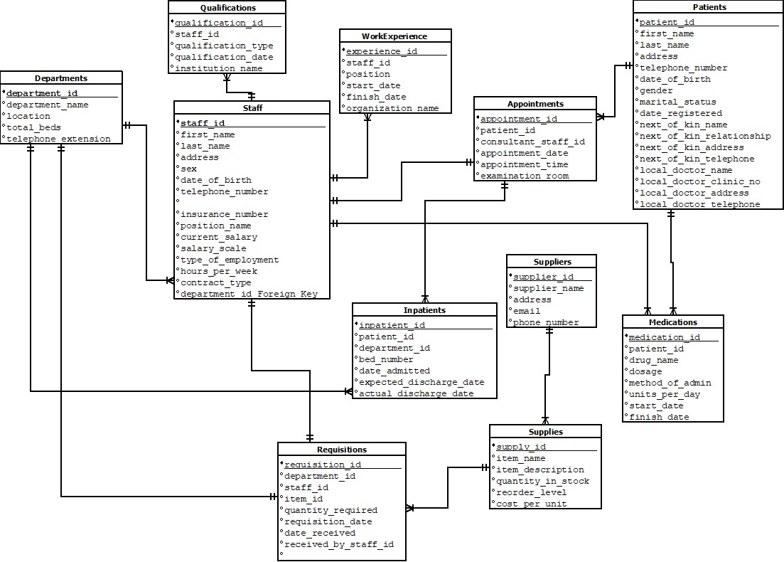
Figure.1 ERD Diagram

Database Schema Overview for BostonHospital
The BostonHospital database schema includes multiple tables, each with primary keys, foreign keys, and indexes to ensure efficient data storage, retrieval, and performance optimization. Below is a detailed schema outlining the tables, indexes, and primary keys:
- Departments Table
  - Columns:
    - department_id (INT) - Primary Key o department_name (VARCHAR(255)) o location (VARCHAR(255))
    - total_beds (INT)
    - telephone_extension (VARCHAR(10))
  - Indexes:
    - idx_department_name - Indexed for quick search by department name. • Primary Key: department_id
- Staff Table
  - Columns:
    - staff_id (INT) - Primary Key o first_name (VARCHAR(255)) o last_name (VARCHAR(255)) o address (VARCHAR(255)) o sex (CHAR(1)) o date_of_birth (DATE) o telephone_number (VARCHAR(15)) o insurance_number (VARCHAR(20)) o position_name (VARCHAR(255)) o current_salary (DECIMAL(10, 2)) o salary_scale (VARCHAR(50)) o type_of_employment (VARCHAR(50))
    - hours_per_week (INT) o contract_type (VARCHAR(50))
    - department_id (INT) - Foreign Key from Departments
  - Indexes:
    - idx_staff_name - Indexed for quick search by staff name.
  - Primary Key: staff_id
  - Foreign Key: department_id (References Departments(department_id))
- Qualifications Table
  - Columns:
    - qualification_id (INT) - Primary Key o staff_id (INT) - Foreign Key from Staff o qualification_type (VARCHAR(255)) o qualification_date (DATE) o institution_name (VARCHAR(255))
  - Primary Key: qualification_id
  - Foreign Key: staff_id (References Staff(staff_id))
- WorkExperience Table
  - Columns:
    - experience_id (INT) - Primary Key
    - staff_id (INT) - Foreign Key from Staff o position (VARCHAR(255)) o start_date (DATE) o finish_date (DATE)
    - organization_name (VARCHAR(255))
  - Primary Key: experience_id
  - Foreign Key: staff_id (References Staff(staff_id))
- Patients Table
  - Columns:
    - patient_id (INT) - Primary Key o first_name (VARCHAR(255)) o last_name (VARCHAR(255)) o address (VARCHAR(255)) o telephone_number (VARCHAR(15))
    - date_of_birth (DATE) o gender (CHAR(1)) o marital_status (VARCHAR(50)) o date_registered (DATE) o next_of_kin_name (VARCHAR(255)) o next_of_kin_relationship (VARCHAR(255)) o next_of_kin_address (VARCHAR(255)) o next_of_kin_telephone (VARCHAR(15)) o local_doctor_name (VARCHAR(255)) o local_doctor_clinic_no (VARCHAR(50)) o local_doctor_address (VARCHAR(255)) o local_doctor_telephone (VARCHAR(15))
  - Indexes:
    - idx_patient_name - Indexed for quick search by patient name.
  - Primary Key: patient_id
- Appointments Table
  - Columns:
    - appointment_id (INT) - Primary Key o patient_id (INT) - Foreign Key from Patients o consultant_staff_id (INT) - Foreign Key from Staff
    - appointment_date (DATE) o appointment_time (TIME) o examination_room (VARCHAR(50))
  - Indexes:
    - idx_appointment_date - Indexed for quick search by appointment date.
  - Primary Key: appointment_id
  - Foreign Key: patient_id (References Patients(patient_id))
  - Foreign Key: consultant_staff_id (References Staff(staff_id))
- Inpatients Table
  - Columns:
    - inpatient_id (INT) - Primary Key o patient_id (INT) - Foreign Key from Patients o department_id (INT) - Foreign Key from Departments
    - bed_number (INT) o date_admitted (DATE) o expected_discharge_date (DATE) o actual_discharge_date (DATE) • Indexes:
    - idx_inpatient_admission - Indexed for quick search by admission date.
  - Primary Key: inpatient_id
  - Foreign Key: patient_id (References Patients(patient_id))
  - Foreign Key: department_id (References Departments(department_id))
- Medications Table
  - Columns:
    - medication_id (INT) - Primary Key o patient_id (INT) - Foreign Key from Patients o drug_name (VARCHAR(255)) o dosage (VARCHAR(50)) o method_of_admin (VARCHAR(50))
    - units_per_day (INT) o start_date (DATE) o finish_date (DATE)
  - Primary Key: medication_id
  - Foreign Key: patient_id (References Patients(patient_id))
- Supplies Table
  - Columns:
    - supply_id (INT) - Primary Key o item_name (VARCHAR(255)) o item_description (TEXT) o quantity_in_stock (INT) o reorder_level (INT)
    - cost_per_unit (DECIMAL(10, 2))
  - Primary Key: supply_id
- Requisitions Table
  - Columns:
    - requisition_id (INT) - Primary Key
    - department_id (INT) - Foreign Key from Departments o staff_id (INT) - Foreign Key from Staff o item_id (INT) - Foreign Key from Supplies o quantity_required (INT) o requisition_date (DATE) o date_received (DATE)
    - received_by_staff_id (INT) - Foreign Key from Staff
  - Primary Key: requisition_id
  - Foreign Key: department_id (References Departments(department_id))
  - Foreign Key: staff_id (References Staff(staff_id))
  - Foreign Key: item_id (References Supplies(supply_id))
- Suppliers Table
  - Columns:
    - supplier_id (INT) - Primary Key
    - supplier_name (VARCHAR(255)) o address (VARCHAR(255)) o email (VARCHAR(255)) o phone_number (VARCHAR(15)) o fax_number (VARCHAR(15))
  - Primary Key: supplier_id
Summary of Indexes and Keys:
  - Indexes:
    - idx_department_name - Index on department_name for fast lookup in Departments table. o idx_staff_name - Index on first_name and last_name for fast lookup in Staff table.
    - idx_patient_name - Index on first_name and last_name for fast lookup in Patients table.
    - idx_appointment_date - Index on appointment_date for fast lookup in Appointments table. o idx_inpatient_admission - Index on date_admitted for fast lookup in Inpatients table.
  - Primary Keys:
    - Every table has a primary key to uniquely identify each record (e.g., department_id for Departments, staff_id for Staff, etc.).
  - Foreign Keys:
    - Staff table references Departments with department_id. o Qualifications and WorkExperience reference Staff with staff_id. o Appointments references Patients and Staff. o Inpatients references Patients and Departments. o Medications references Patients. o Requisitions references Departments, Staff, and Supplies

SQL SCRIPT to create the Database including Tables, Indexes, and populating tables
CREATE DATABASE BostonHospital;
USE BostonHospital;
CREATE TABLE Departments ( department_id INT PRIMARY KEY, department_name VARCHAR(255), location VARCHAR(255), total_beds INT, telephone_extension VARCHAR(10)
);
CREATE TABLE Staff ( staff_id INT PRIMARY KEY, first_name VARCHAR(255), last_name VARCHAR(255), address VARCHAR(255), sex CHAR(1), date_of_birth DATE, telephone_number VARCHAR(15), insurance_number VARCHAR(20), position_name VARCHAR(255), current_salary DECIMAL(10, 2), salary_scale VARCHAR(50), type_of_employment VARCHAR(50), hours_per_week INT, contract_type VARCHAR(50) -- Permanent or Temporary
);
CREATE TABLE Qualifications ( qualification_id INT PRIMARY KEY,
staff_id INT, qualification_type VARCHAR(255), qualification_date DATE, institution_name VARCHAR(255),
FOREIGN KEY (staff_id) REFERENCES Staff(staff_id)
);
CREATE TABLE WorkExperience ( experience_id INT PRIMARY KEY,
staff_id INT, position VARCHAR(255), start_date DATE, finish_date DATE, organization_name VARCHAR(255),
FOREIGN KEY (staff_id) REFERENCES Staff(staff_id)
);
CREATE TABLE Patients ( patient_id INT PRIMARY KEY, first_name VARCHAR(255), last_name VARCHAR(255), address VARCHAR(255), telephone_number VARCHAR(15),
date_of_birth DATE, gender CHAR(1), marital_status VARCHAR(50), date_registered DATE, next_of_kin_name VARCHAR(255), next_of_kin_relationship VARCHAR(255), next_of_kin_address VARCHAR(255), next_of_kin_telephone VARCHAR(15), local_doctor_name VARCHAR(255), local_doctor_clinic_no VARCHAR(50), local_doctor_address VARCHAR(255), local_doctor_telephone VARCHAR(15)
);
CREATE TABLE Appointments ( appointment_id INT PRIMARY KEY, patient_id INT, consultant_staff_id INT, appointment_date DATE, appointment_time TIME, examination_room VARCHAR(50),
FOREIGN KEY (patient_id) REFERENCES Patients(patient_id),
FOREIGN KEY (consultant_staff_id) REFERENCES Staff(staff_id)
);
CREATE TABLE Inpatients ( inpatient_id INT PRIMARY KEY,
patient_id INT, department_id INT, bed_number INT, date_admitted DATE, expected_discharge_date DATE, actual_discharge_date DATE,
FOREIGN KEY (patient_id) REFERENCES Patients(patient_id),
FOREIGN KEY (department_id) REFERENCES Departments(department_id)
);
CREATE TABLE Medications ( medication_id INT PRIMARY KEY,
patient_id INT,
drug_name VARCHAR(255), dosage VARCHAR(50), method_of_admin VARCHAR(50),
units_per_day INT, start_date DATE, finish_date DATE,
FOREIGN KEY (patient_id) REFERENCES Patients(patient_id)
);
CREATE TABLE Supplies ( supply_id INT PRIMARY KEY, item_name VARCHAR(255), item_description TEXT, quantity_in_stock INT, reorder_level INT, cost_per_unit DECIMAL(10, 2)
);
CREATE TABLE Requisitions ( requisition_id INT PRIMARY KEY, department_id INT, staff_id INT,
item_id INT, quantity_required INT, requisition_date DATE, date_received DATE, received_by_staff_id INT,
FOREIGN KEY (department_id) REFERENCES Departments(department_id),
FOREIGN KEY (staff_id) REFERENCES Staff(staff_id),
FOREIGN KEY (item_id) REFERENCES Supplies(supply_id)
);
CREATE TABLE Suppliers ( supplier_id INT PRIMARY KEY, supplier_name VARCHAR(255), address VARCHAR(255), email VARCHAR(255), phone_number VARCHAR(15), fax_number VARCHAR(15)
);
--inserting populating the data tables
INSERT INTO Departments (department_id, department_name, location, total_beds, telephone_extension)
VALUES
(1, 'Cardiology', 'Building A, 2nd Floor', 50, '101'),
(2, 'Neurology', 'Building B, 3rd Floor', 40, '102'),
(3, 'Pediatrics', 'Building A, 3rd Floor', 30, '103'),
(4, 'Emergency', 'Building C, Ground Floor', 25, '104');
INSERT INTO Staff (staff_id, first_name, last_name, address, sex, date_of_birth, telephone_number, insurance_number, position_name, current_salary, salary_scale, type_of_employment, hours_per_week, contract_type)
VALUES
(1, 'John', 'Doe', '123 Elm St, Boston, MA', 'M', '1980-05-15', '555-1234', 'INS12345',
'Doctor', 120000.00, 'S1', 'Full-time', 40, 'Permanent'),
(2, 'Jane', 'Smith', '456 Oak St, Boston, MA', 'F', '1975-08-20', '555-5678', 'INS67890',
'Nurse', 80000.00, 'S2', 'Full-time', 40, 'Permanent'),
(3, 'Mary', 'Johnson', '789 Pine St, Boston, MA', 'F', '1990-02-25', '555-9101', 'INS11223',
'Technician', 50000.00, 'S3', 'Part-time', 30, 'Temporary');
INSERT INTO Qualifications (qualification_id, staff_id, qualification_type, qualification_date, institution_name)
VALUES
(1, 1, 'Medical Degree', '2004-06-10', 'Harvard Medical School'),
(2, 2, 'Registered Nurse', '1998-04-15', 'Boston University'),
(3, 3, 'Laboratory Technician', '2015-08-15', 'St. Peter Clinic');
INSERT INTO WorkExperience (experience_id, staff_id, position, start_date, finish_date, organization_name)
VALUES
(1, 1, 'Resident Doctor', '2005-07-01', '2010-06-30', 'Boston General Hospital'),
(2, 2, 'Nurse', '2000-08-01', '2024-12-12', 'Boston General Hospital'),
(3, 3, 'Lab Technician', '2015-09-01', '2023-12-12', 'St. Peter Clinic');
INSERT INTO Patients (patient_id, first_name, last_name, address, telephone_number, date_of_birth, gender, marital_status, date_registered, next_of_kin_name, next_of_kin_relationship, next_of_kin_address, next_of_kin_telephone, local_doctor_name, local_doctor_clinic_no, local_doctor_address, local_doctor_telephone)
VALUES
(1, 'Robert', 'Green', '101 Maple St, Boston, MA', '555-3344', '1985-04-22', 'M', 'Single',
'2024-06-10', 'Alice Green', 'Mother', '101 Maple St, Boston, MA', '555-5566', 'Dr. Johnson',
'CL12345', '101 Healthcare St, Boston, MA', '555-1122'),
(2, 'Sarah', 'Blue', '202 Birch St, Boston, MA', '555-7788', '1990-07-15', 'F', 'Married', '2024-
06-11', 'Michael Blue', 'Husband', '202 Birch St, Boston, MA', '555-8899', 'Dr. Lee',
'CL98765', '202 Healthcare St, Boston, MA', '555-2233');
INSERT INTO Appointments (appointment_id, patient_id, consultant_staff_id, appointment_date, appointment_time, examination_room)
VALUES
(1, 1, 1, '2024-06-15', '09:00:00', 'Room A'),
(2, 2, 2, '2024-06-16', '10:30:00', 'Room B');
INSERT INTO Inpatients (inpatient_id, patient_id, department_id, bed_number, date_admitted, expected_discharge_date, actual_discharge_date)
VALUES
(1, 1, 1, 12, '2024-06-15', '2024-06-22', NULL),
(2, 2, 2, 3, '2024-06-16', '2024-06-23', NULL);
INSERT INTO Medications (medication_id, patient_id, drug_name, dosage, method_of_admin, units_per_day, start_date, finish_date)
VALUES
(1, 1, 'Aspirin', '500mg', 'Oral', 2, '2024-06-15', '2024-06-20'),
(2, 2, 'Ibuprofen', '200mg', 'Oral', 3, '2024-06-16', '2024-06-18');
INSERT INTO Supplies (supply_id, item_name, item_description, quantity_in_stock, reorder_level, cost_per_unit)
VALUES
(1, 'Bandages', 'Sterile bandages for wound care', 500, 50, 2.50),
(2, 'Syringes', 'Disposable syringes for injections', 1000, 100, 0.75);
INSERT INTO Requisitions (requisition_id, department_id, staff_id, item_id, quantity_required, requisition_date, date_received, received_by_staff_id)
VALUES
(1, 1, 1, 1, 100, '2024-06-15', '2024-06-16', 2),
(2, 2, 2, 2, 200, '2024-06-16', '2024-06-17', 3);
INSERT INTO Suppliers (supplier_id, supplier_name, address, email, phone_number, fax_number)
VALUES
(1, 'Medical Supplies Inc.', '123 Health St, Boston, MA', 'sales@medsupplies.com', '5551122', '555-3344'),
(2, 'Pharma Co.', '456 Wellness Rd, Boston, MA', 'contact@pharmaco.com', '555-2233', '5554455');

CREATE INDEX idx_department_name ON Departments(department_name);
CREATE INDEX idx_staff_name ON Staff(first_name, last_name);
CREATE INDEX idx_patient_name ON Patients(first_name, last_name);
CREATE INDEX idx_appointment_date ON Appointments(appointment_date); CREATE INDEX idx_inpatient_admission ON Inpatients(date_admitted);

ALTER TABLE Staff
ADD department_id INT;

ALTER TABLE Staff
ADD CONSTRAINT fk_department
FOREIGN KEY (department_id) REFERENCES Departments(department_id); CREATE TABLE Staff_Department (
staff_id INT, department_id INT,
PRIMARY KEY (staff_id, department_id),
FOREIGN KEY (staff_id) REFERENCES Staff(staff_id),
FOREIGN KEY (department_id) REFERENCES Departments(department_id)
);
UPDATE Staff
SET department_id = 1
WHERE staff_id = 1; -- Assigning staff_id 1 (John Doe) to the 'Cardiology' department

UPDATE Staff
SET department_id = 2
WHERE staff_id = 2; -- Assigning staff_id 2 (Jane Smith) to the 'Neurology' department

UPDATE Staff
SET department_id = 3
WHERE staff_id = 3; -- Assigning staff_id 3 (Mary Johnson) to the 'Pediatrics' department
DROP TABLE IF EXISTS Staff_Department CASCADE;

CREATE TABLE Staff_Department ( staff_id INT NOT NULL, department_id INT NOT NULL,
PRIMARY KEY (staff_id, department_id),
FOREIGN KEY (staff_id) REFERENCES Staff(staff_id),
FOREIGN KEY (department_id) REFERENCES Departments(department_id)
);

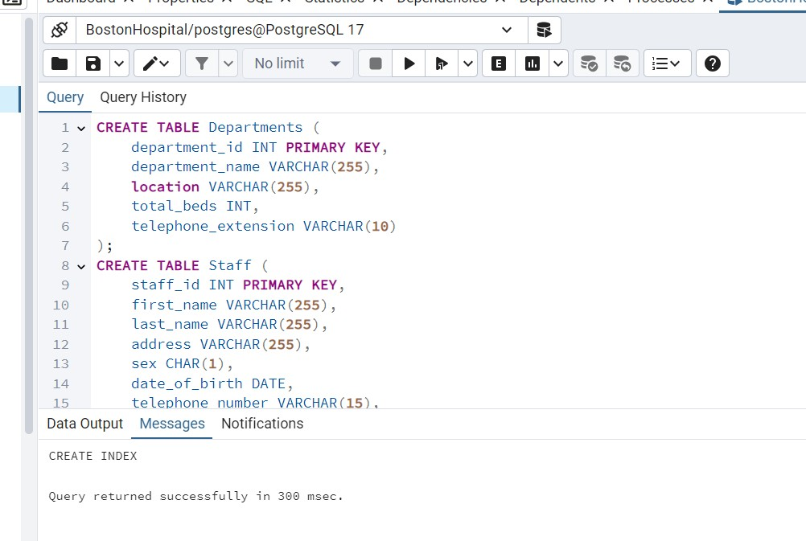

SQL Scripts to create views to support the Reporting
View for Total Patient Count per Department
CREATE VIEW view_patient_count_per_department AS
SELECT d.department_name, COUNT(i.patient_id) AS total_patients
FROM Departments d
LEFT JOIN Inpatients i ON d.department_id = i.department_id
GROUP BY d.department_name;
SELECT * FROM view_patient_count_per_department;
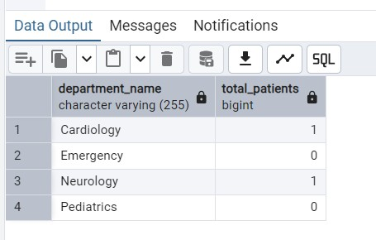
View for Staff and Their Department Information
CREATE OR REPLACE VIEW StaffDepartmentView AS
SELECT
s.staff_id,
s.first_name,
s.last_name,
s.position_name,
s.current_salary,
s.salary_scale,
s.type_of_employment,
s.hours_per_week,
s.contract_type,
d.department_name,
d.location AS department_location
FROM
Staff s
JOIN
Departments d ON s.department_id = d.department_id;
SELECT * FROM StaffDepartmentView;
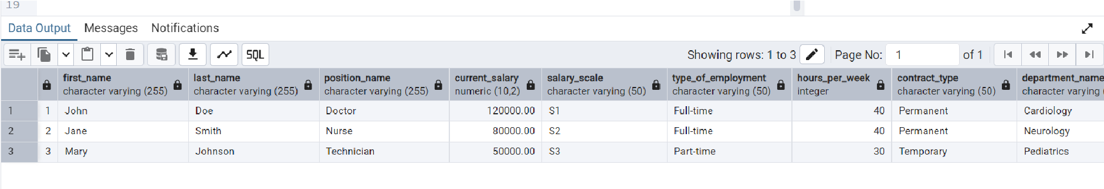
View for Staff Qualifications
CREATE VIEW StaffQualificationsView AS
SELECT
s.staff_id,
s.first_name,
s.last_name,
q.qualification_type,
q.qualification_date,
q.institution_name
FROM
Staff s
JOIN
Qualifications q ON s.staff_id = q.staff_id;

SELECT * FROM StaffQualificationsView;

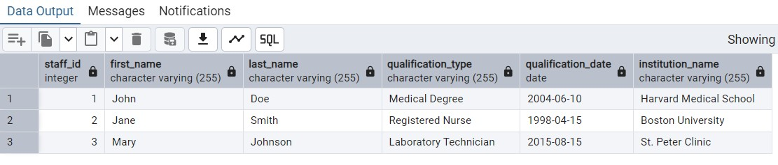
View for Work Experience of Staff

CREATE VIEW StaffWorkExperienceView AS
SELECT
s.staff_id,
s.first_name,
s.last_name,
w.position,
w.start_date,
w.finish_date,
w.organization_name
FROM
Staff s
JOIN
WorkExperience w ON s.staff_id = w.staff_id;

SELECT * FROM StaffWorkExperienceView;
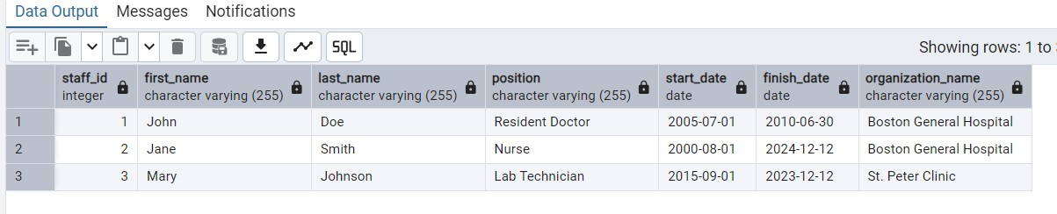
View for Patient Appointments
CREATE VIEW PatientAppointmentsView AS
SELECT
p.patient_id,
p.first_name AS patient_first_name,
p.last_name AS patient_last_name,
p.date_of_birth AS patient_dob,
p.gender AS patient_gender,
a.appointment_date,
a.appointment_time,
a.examination_room,
s.first_name AS consultant_first_name,
s.last_name AS consultant_last_name,
s.position_name AS consultant_position
FROM
Patients p
JOIN
Appointments a ON p.patient_id = a.patient_id
JOIN
Staff s ON a.consultant_staff_id = s.staff_id;

SELECT * FROM PatientAppointmentsView;
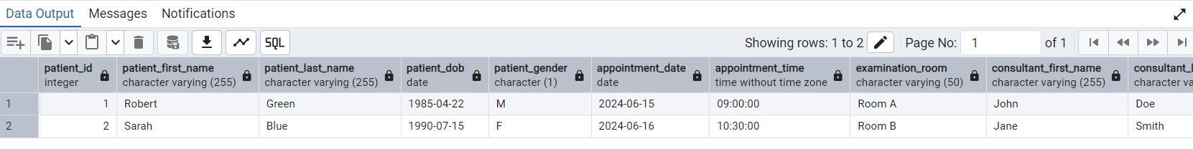
View for Inpatients in Each Department
CREATE VIEW InpatientDepartmentsView AS
SELECT
i.inpatient_id,
p.first_name AS patient_first_name,
p.last_name AS patient_last_name,
p.date_of_birth AS patient_dob,
d.department_name,
i.bed_number,
i.date_admitted,
i.expected_discharge_date,
i.actual_discharge_date
FROM
Inpatients i
JOIN
Patients p ON i.patient_id = p.patient_id
JOIN
Departments d ON i.department_id = d.department_id;

SELECT * FROM InpatientDepartmentsView;
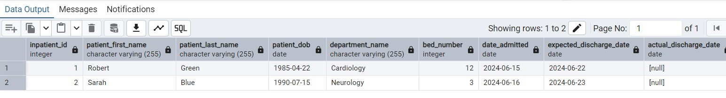
View for Medications Given to Patients
CREATE VIEW PatientMedicationsView AS
SELECT
p.patient_id,
p.first_name AS patient_first_name,
p.last_name AS patient_last_name,
p.date_of_birth AS patient_dob,
m.drug_name,
m.dosage,
m.method_of_admin,
m.units_per_day,
m.start_date,
m.finish_date
FROM
Medications m
JOIN
Patients p ON m.patient_id = p.patient_id;

SELECT * FROM PatientMedicationsView;
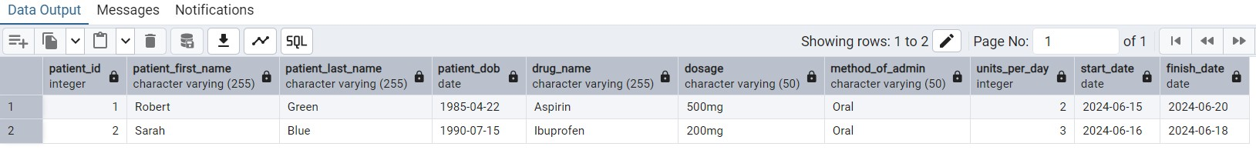
View for Supply Requisitions
CREATE VIEW SupplyRequisitionsView AS
SELECT
r.requisition_id,
r.requisition_date,
r.date_received,
r.quantity_required,
r.received_by_staff_id,
s.first_name AS staff_first_name,
s.last_name AS staff_last_name,
d.department_name, sup.item_name, sup.quantity_in_stock, sup.reorder_level
FROM
Requisitions r
JOIN
Staff s ON r.staff_id = s.staff_id
JOIN
Departments d ON r.department_id = d.department_id
JOIN
Supplies sup ON r.item_id = sup.supply_id;

SELECT * FROM SupplyRequisitionsView;
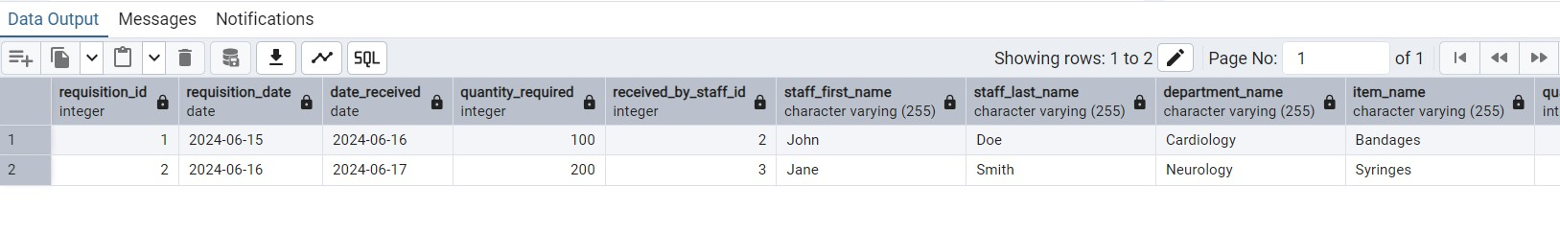

View for Patients' Next of Kin Details
CREATE VIEW PatientNextOfKinView AS
SELECT
p.patient_id,
p.first_name AS patient_first_name,
p.last_name AS patient_last_name,
p.date_of_birth AS patient_dob,
p.next_of_kin_name,
p.next_of_kin_relationship,
p.next_of_kin_address,
p.next_of_kin_telephone
FROM
Patients p;

SELECT * FROM PatientNextOfKinView;
View for Inpatient Medication Details

CREATE VIEW InpatientMedicationView AS
SELECT
i.inpatient_id,
p.first_name AS patient_first_name,
p.last_name AS patient_last_name,
m.drug_name,
m.dosage,
m.method_of_admin,
m.units_per_day,
m.start_date,
m.finish_date,
d.department_name AS department
FROM
Medications m
JOIN
Patients p ON m.patient_id = p.patient_id
JOIN
Inpatients i ON p.patient_id = i.patient_id
JOIN
Departments d ON i.department_id = d.department_id;

SELECT * FROM InpatientMedicationView;
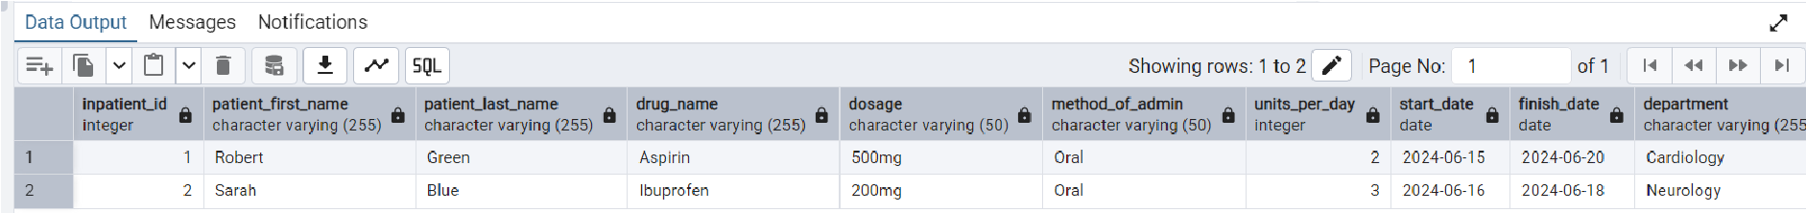

STORED PROCEDURES
Insert New Department
CREATE OR REPLACE FUNCTION insert_department(
p_department_name VARCHAR, p_location VARCHAR,
p_total_beds INT, p_telephone_extension VARCHAR
) RETURNS VOID AS $$
BEGIN
INSERT INTO Departments (department_name, location, total_beds, telephone_extension)
VALUES (p_department_name, p_location, p_total_beds, p_telephone_extension);
END;
$$ LANGUAGE plpgsql;
SELECT * FROM Departments;
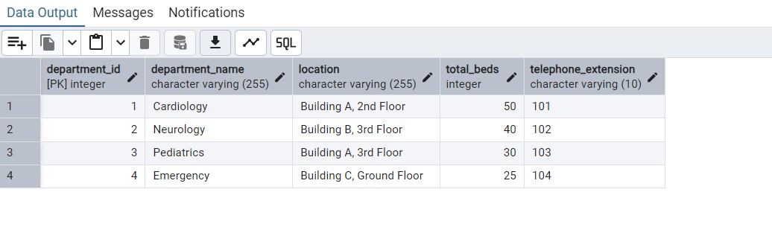
Insert New Staff
CREATE OR REPLACE FUNCTION insert_staff( p_first_name VARCHAR, p_last_name VARCHAR,
p_address VARCHAR, p_sex CHAR(1), p_date_of_birth DATE, p_telephone_number VARCHAR, p_insurance_number VARCHAR, p_position_name VARCHAR, p_current_salary DECIMAL(10, 2), p_salary_scale VARCHAR(50), p_type_of_employment VARCHAR(50), p_hours_per_week INT, p_contract_type VARCHAR(50)
) RETURNS VOID AS $$
BEGIN
INSERT INTO Staff (first_name, last_name, address, sex, date_of_birth, telephone_number, insurance_number, position_name, current_salary, salary_scale, type_of_employment, hours_per_week, contract_type)
VALUES (p_first_name, p_last_name, p_address, p_sex, p_date_of_birth, p_telephone_number, p_insurance_number, p_position_name, p_current_salary, p_salary_scale, p_type_of_employment, p_hours_per_week, p_contract_type);
END;
$$ LANGUAGE plpgsql;
SELECT * FROM Staff;
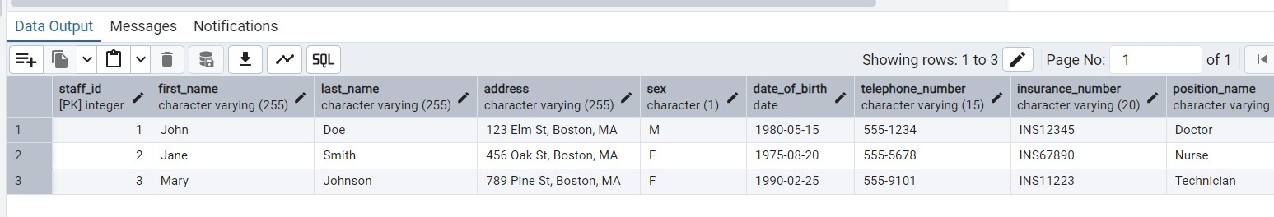
Assign Staff to Department

CREATE OR REPLACE FUNCTION assign_staff_to_department(
p_staff_id INT, p_department_id INT
) RETURNS VOID AS $$
BEGIN
-- Check if the staff_id and department_id pair already exists
IF NOT EXISTS (
SELECT 1 FROM Staff_Department
WHERE staff_id = p_staff_id AND department_id = p_department_id
) THEN
-- Insert the new pair only if it doesn't exist
INSERT INTO Staff_Department (staff_id, department_id)
VALUES (p_staff_id, p_department_id);
END IF;
END;
$$ LANGUAGE plpgsql;
DROP TABLE IF EXISTS Staff_Department CASCADE;

CREATE TABLE Staff_Department ( staff_id INT NOT NULL, department_id INT NOT NULL,
PRIMARY KEY (staff_id, department_id),
FOREIGN KEY (staff_id) REFERENCES Staff(staff_id),
FOREIGN KEY (department_id) REFERENCES Departments(department_id)
);
SELECT assign_staff_to_department(1, 2);
SELECT assign_staff_to_department(1, 2); -- This will not throw an error now
SELECT * FROM Staff_Department;

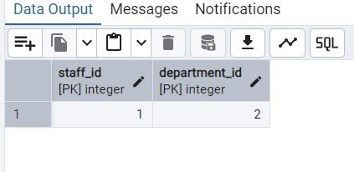

Add Medications
CREATE OR REPLACE PROCEDURE AddMedication(
p_medication_id INT, p_patient_id INT,
p_drug_name VARCHAR, p_dosage VARCHAR, p_method_of_admin VARCHAR, p_units_per_day INT, p_start_date DATE, p_finish_date DATE
)
LANGUAGE plpgsql
AS $$
BEGIN
INSERT INTO Medications ( medication_id, patient_id, drug_name, dosage, method_of_admin, units_per_day, start_date, finish_date
)
VALUES ( p_medication_id, p_patient_id, p_drug_name, p_dosage, p_method_of_admin, p_units_per_day, p_start_date, p_finish_date
);
END;
$$;
CALL AddMedication(
101, -- medication_id
1, -- patient_id (must exist in Patients table)
'Amoxicillin', -- drug_name
'250mg', -- dosage
'Oral', -- method_of_admin
3, -- units_per_day
'2024-07-20', -- start_date
'2024-07-27' -- finish_date
);
SELECT * FROM Medications;
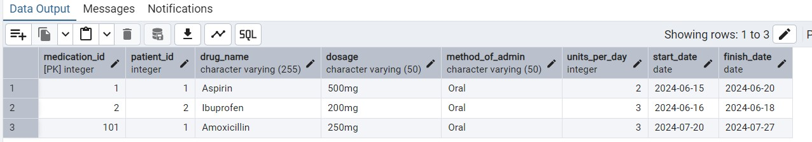
Procedure to Add Multiple Medications
CREATE OR REPLACE PROCEDURE AddMultipleMedications(
p_medication_records JSON
)
LANGUAGE plpgsql
AS $$
DECLARE
record JSON;
BEGIN
-- Iterate over each JSON element in the array
FOR record IN SELECT * FROM json_array_elements(p_medication_records)
LOOP
INSERT INTO Medications (
medication_id, patient_id, drug_name, dosage, method_of_admin, units_per_day, start_date, finish_date
)
VALUES (
(record->>'medication_id')::INT, (record->>'patient_id')::INT, record->>'drug_name', record->>'dosage', record->>'method_of_admin',
(record->>'units_per_day')::INT,
(record->>'start_date')::DATE,
(record->>'finish_date')::DATE
);
END LOOP;
END;
$$;
CALL AddMultipleMedications(
'[
{"medication_id": 102, "patient_id": 1, "drug_name": "Paracetamol", "dosage":
"500mg", "method_of_admin": "Oral", "units_per_day": 2, "start_date": "2024-07-22",
"finish_date": "2024-07-29"},
{"medication_id": 103, "patient_id": 2, "drug_name": "Metformin", "dosage": "850mg",
"method_of_admin": "Oral", "units_per_day": 1, "start_date": "2024-07-23", "finish_date": "2024-07-30"}
]'
);
SELECT * FROM Medications;

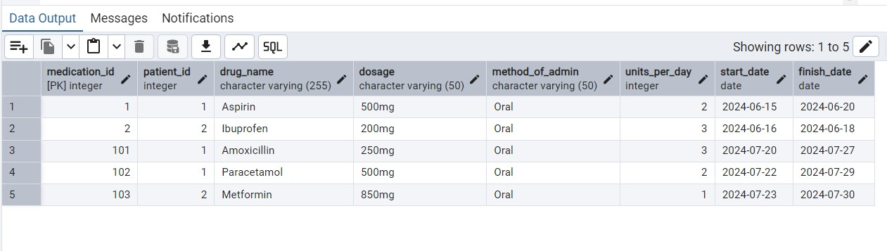
Procedure to View Medication Details for a Patient
CREATE OR REPLACE FUNCTION GetPatientMedications(
p_patient_id INT
)
RETURNS TABLE (
medication_id INT, patient_id INT,
drug_name VARCHAR, dosage VARCHAR, method_of_admin VARCHAR,
units_per_day INT, start_date DATE, finish_date DATE
)
LANGUAGE plpgsql
AS $$
BEGIN
-- Return medications for the given patient_id
RETURN QUERY
SELECT m.medication_id, m.patient_id, m.drug_name, m.dosage,
m.method_of_admin, m.units_per_day, m.start_date, m.finish_date
FROM Medications m
WHERE m.patient_id = p_patient_id;
END;
$$;
-- Call the function and view the results for patient_id = 1
SELECT * FROM GetPatientMedications(1);
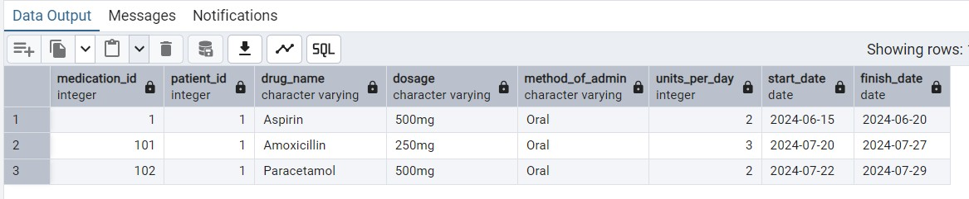

Conclusion
In this project, we designed a robust database schema for BostonHospital, encompassing the creation of tables, relationships, and essential keys. We also developed an Entity-Relationship Diagram (ERD) to visualize the structure and drafted SQL scripts for views and stored procedures to streamline data retrieval and automation. The schema effectively organizes critical information related to hospital operations, including departments, staff, patients, and appointments. This design ensures high performance, data integrity, and operational efficiency, enabling smooth management of hospital processes and resources.

